**Problem Analysis**

**Content**

**Statement** 2

**Functional Requirements** 3

**Object diagram** 5

**Traceability** 6

**Flowcharts** 8

FR1 8

FR3 9

FR4 10

FR5 11

FR7 12

# **Statement**

A friend of your Algorithm teacher likes angels very much and has commented that it would be interesting to have a small application that reminds her of their important dates, type, representative color, among others. Her teacher, having the need to pose a problem to her APO1 students, began asking her friend and this is what she told her:

Angels are categorized into several types: archangels, cherubs, seraphim.

All angels of the same type are grouped into a legion, for example: the archangel angels are grouped into a legion called "Highest Maxim." The cherub angels are grouped in a legion called "Liberi" and finally the seraphim are grouped in the legion "Seraphim".

Note: For this exercise we are only interested in the legion of the archangels.

Each archangel has a name (which ends in the syllable "el"), a photo, a prayer, a date of celebration (day and month) and a power. Among some of the recognized powers are: protection, health, abundance, justice, loyalty, but the user can create more powers. Each archangel is assigned a special candle, which has a color, a size, an essence and a degree of illuminance.

# **Functional Requirements**

Table 1 Functional Requirements

|  |  |
| --- | --- |
| Name | Description |
| FR1 | Enter the archangels (there is only one archangel per name and there is only one archangel per power) |
| FR2 | Count the archangels entered |
| FR3 | Display the archangel's information given its name |
| FR4 | Display the archangel's information given its power |
| FR5 | Display the celebrations to be held given one month (you must show the name of the archangel, the day of the celebration, the color and the essence of your candle) |
| FR6 | Display all celebrations: Review each of the created angels and concatenate the response with the date of celebration, like this: name of the angel: date of celebration, name of the angel: date of celebration. Example: Miguel: September 29, Rafael: June 10. |
| FR7 | Application should allow the user to add more powers to an archangel specified. |

**UML Class Diagram**

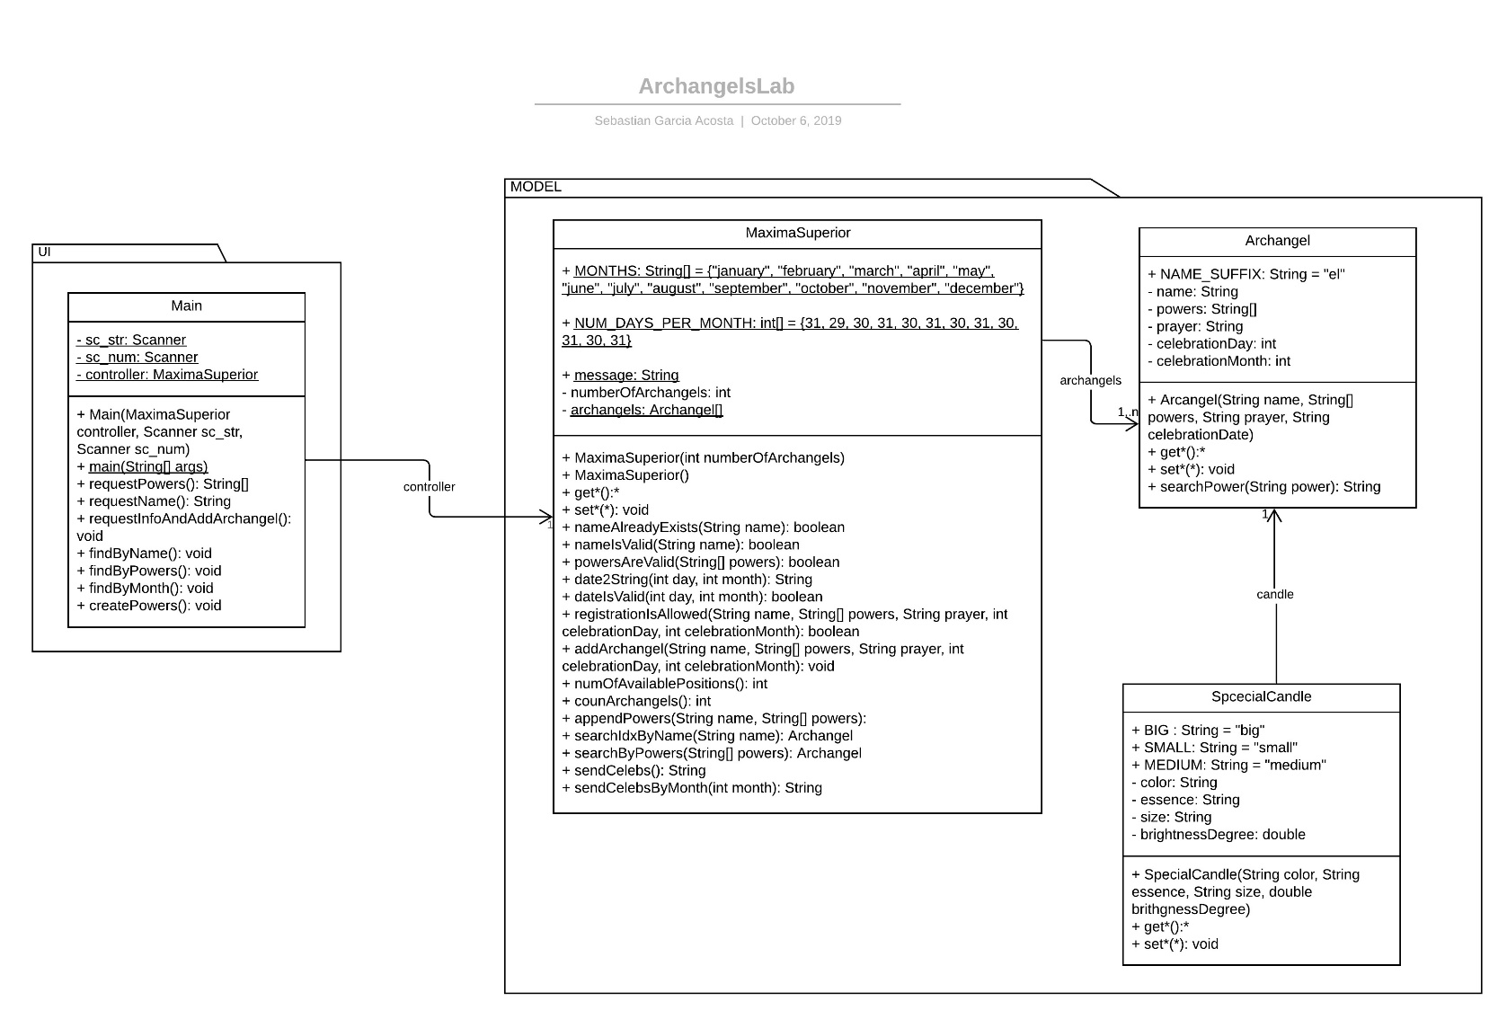

You can find this UML Class Diagram on lucidchart:

<https://www.lucidchart.com/invitations/accept/06bfcad1-247e-4908-86e0-1db9629a2bb7>

# **Object diagram**

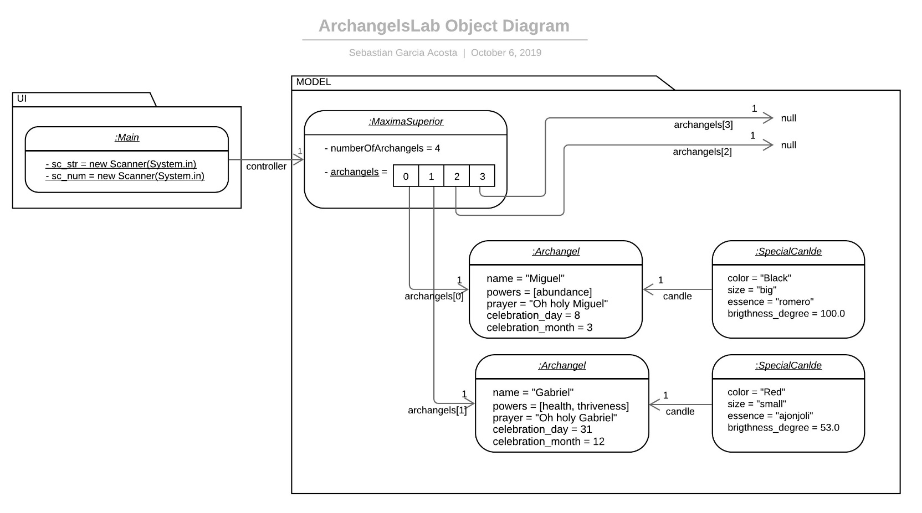

You can find this UML Object Diagram on lucidchart:

<https://www.lucidchart.com/invitations/accept/10d22738-d62a-4f5f-8528-0f363a2620c4>

# **Traceability**

|  |  |  |
| --- | --- | --- |
| FUNCTIONAL REQUIREMENT | CLASS | METHOD |
| FR1 | Main  Main MaximaSuperior  MaximaSuperior  MaximaSuperior  Main  MaximaSuperior  MaximaSuperior  Archangel  MaximaSuperior  MaximaSuperior      MaximaSuperior MaximaSuperior | requestInfoAndAddArchangel()  requestName(String name)  nameIsValid(String name)  nameAlreadyExists(String name)  searchIdxByName(String name)  requestPowers()  powersAreValid(String[] powers)  searchByPowers(String[] powers)  searchPower(String power) RegistrationIsAllowed(String name, String[] powers, int celebration_day, int celebration_month)  addArchangel(int position, String name, String[] powers, String prayer, int celeb_day, int celeb_month, String color, String size, String essence, double brightness_degree)  getNumArchangels() numOfAvailablePositions() |
| FR2 | MaximaSuperior | countArchangels() |
| FR3 | Main MaximaSuperior  Archangel Archangel | findByName() searchIdxByName(String name) getArchangels() toString() |
| FR4 | Main MaximaSuperior  Archangel Archangel | findByPowers() searchByPowers(String[] powers)  searchPower(String power) toString() |
| FR5 | Main MaximaSuperior  Archangel Archangel  Archangel Archangel SpecialCandle SpecialCandle | findByMonth(int month) searchCelebsByMonth(int month) getCelebrationMonth() getName()  getCelebrationDay() getCandle() getColor() getEssence() |
| FR6 | MaximaSuperior MaximaSuperior Archangel  Archangel Archangel MaximaSuperior | showAllCelebs() countArchangels() getName() getCelebrationDay() getCelebrationMonth() date2String(int day, int month) |
| FR7 | Main MaximaSuperior  MaximaSuperior  Main MaximaSuperior  MaximaSuperior  Archangel  MaximaSuperior  MaximaSuperior  Archangel Archangel | createPowers() nameAlreadyExists(String name)  searchIdxByName(String name) requestPowers()  powersAreValid(String[] powers)  searchByPowers(String[] powers)  searchPower(String power) appendPowers(String name, String[] powers) searchIdxByName(String name) getPowers() setPowers() |

# **Flowcharts**

## FR1

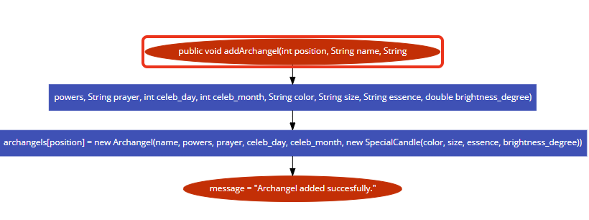 FR2

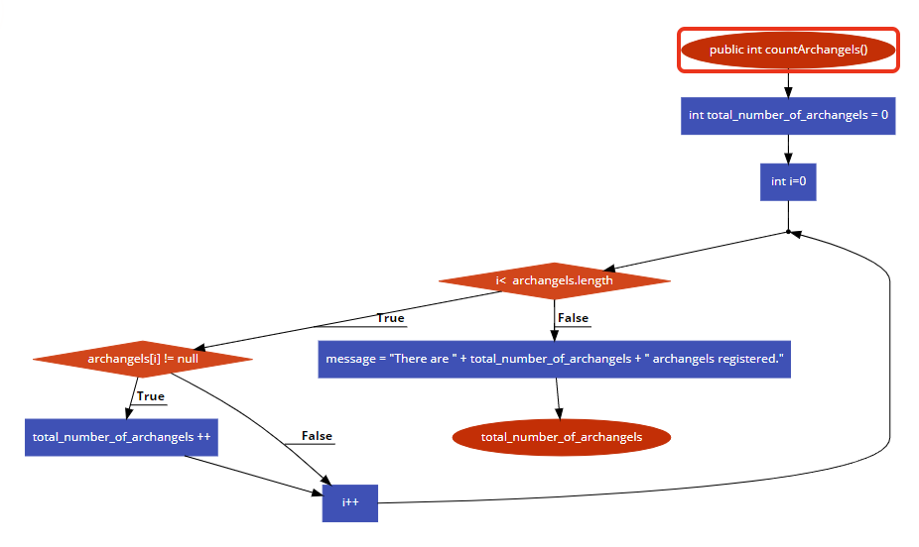

## FR3

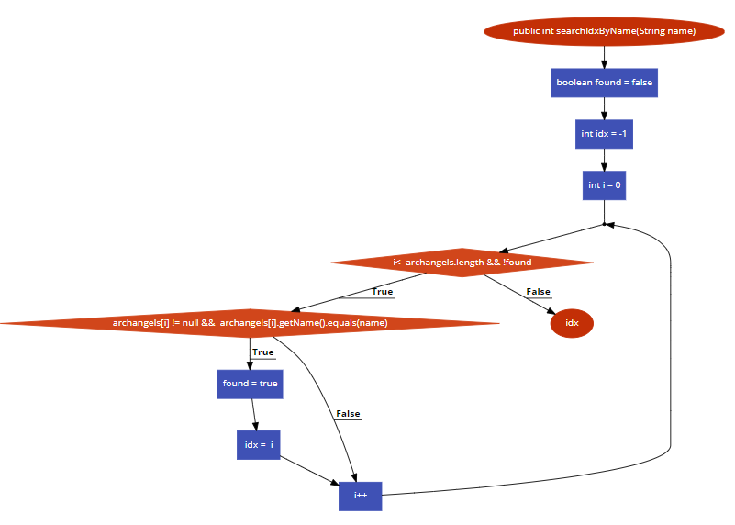

## FR4

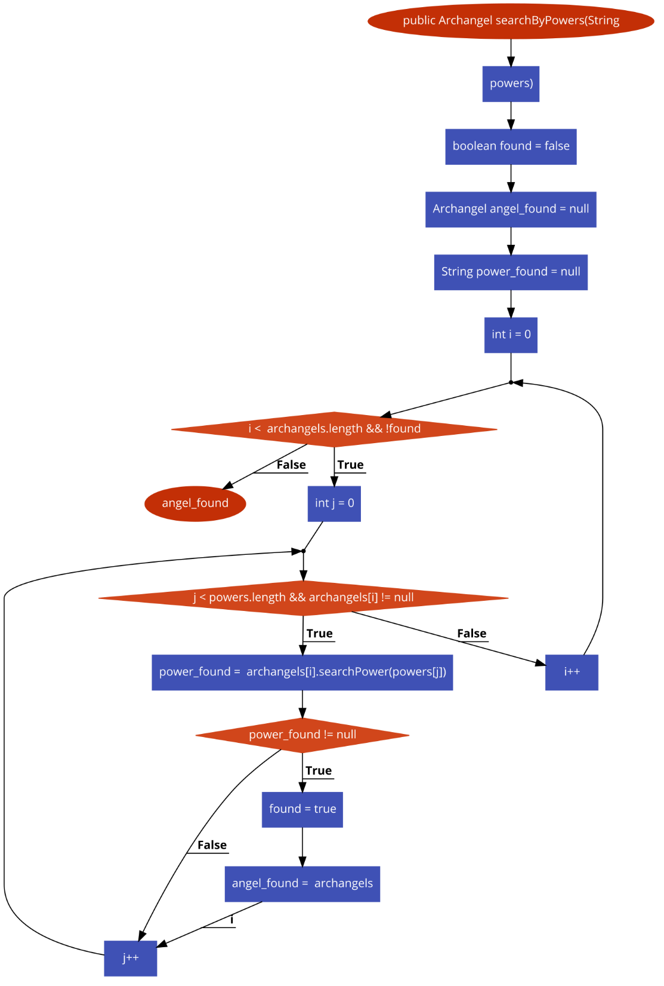

## FR5

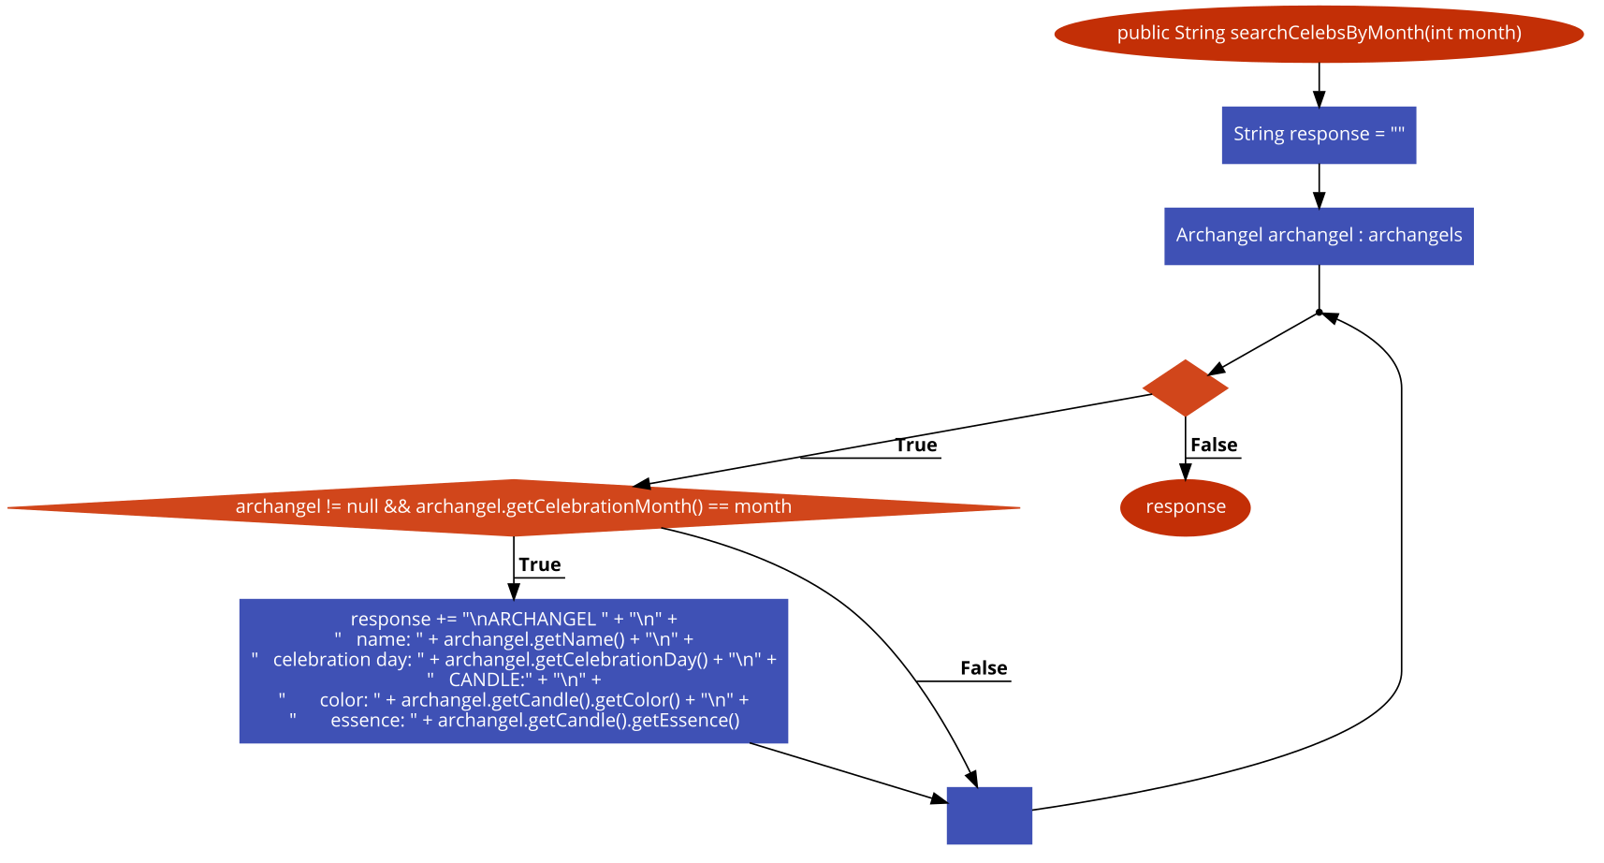   
FR6

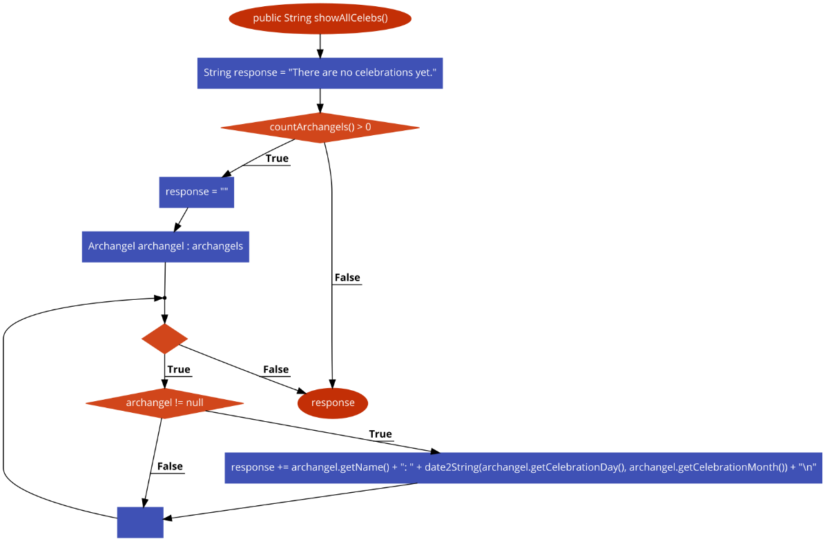

## FR7

